7K samples

inputs = layers.Input(shape=(FFT_BINS,WINDOW_SIZE,2)) # Full window
input_slice = layers.Input(shape=(FFT_BINS,1,2)) # Just the center row that we're trying to predict
conv1 = layers.Conv2D(32, kernel_size=2, activation='relu', padding='valid',
input_shape=[FFT_BINS,WINDOW_SIZE,2])(inputs)
pool1 = layers.MaxPooling2D(pool_size=(2,2), strides=(2,2))(conv1)
conv2 = layers.Conv2D(32, kernel_size=2, activation='relu')(pool1)
pool2 = layers.MaxPooling2D(pool_size=(2,2), strides=(2,2))(conv2)
conv3 = layers.Conv2D(16, kernel_size=1, activation='relu')(pool2) # Seems like making this too big causes OOM
flat = layers.Flatten()(conv3)
dense0 = layers.Dense(2000, activation='relu')(flat)
dense1 = layers.Dense(1500, activation='relu')(dense0)
dense2 = layers.Dense(500, activation='relu')(dense1)
flat_in = layers.Flatten()(input_slice)
merged = layers.concatenate([dense2, flat_in])
outputs = layers.Dense(2*FFT_BINS, activation='linear')(merged)

model = keras.models.Model(inputs=[inputs,input_slice], outputs=outputs)

model.compile(optimizer='Adam', loss='mse')

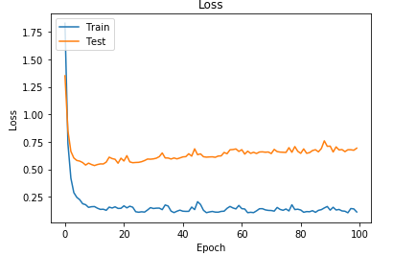

Same network with 27K samples (250 clips)

validation loss mean = 0.176

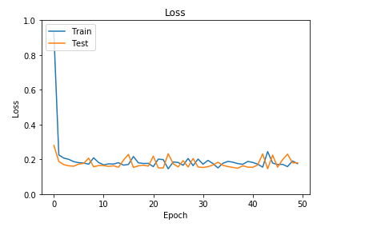

Tried out Nadam – everything else the same, worse results

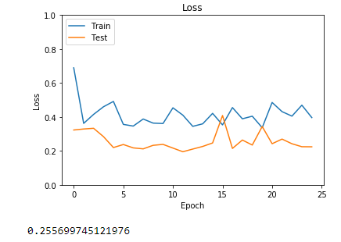

Trying much simplified network (and back to Adam)

inputs = layers.Input(shape=(FFT_BINS,WINDOW_SIZE,2)) # Full window
input_slice = layers.Input(shape=(FFT_BINS,1,2)) # Just the center row that we're trying to predict
conv1 = layers.Conv2D(16, kernel_size=2, activation='relu', padding='valid',
input_shape=[FFT_BINS,WINDOW_SIZE,2])(inputs)
pool1 = layers.MaxPooling2D(pool_size=(2,2), strides=(2,2))(conv1)
flat = layers.Flatten()(pool1)
dense0 = layers.Dense(1000, activation='relu')(flat)
dense2 = layers.Dense(500, activation='relu')(dense0)
flat_in = layers.Flatten()(input_slice)
merged = layers.concatenate([dense2, flat_in])
outputs = layers.Dense(2*FFT_BINS, activation='linear')(merged)

model = keras.models.Model(inputs=[inputs,input_slice], outputs=outputs)

model.compile(optimizer='Adam', loss='mse')

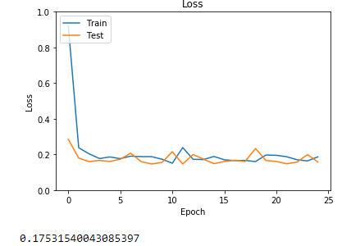

Works about the same as the much more complex one.
Audio is a bit noisy but also slightly cleaner

21 wide frames and smaller first dense layer to avoid OOM, plus extra conv2d

Layer (type) Output Shape Param # Connected to
==================================================================================================
input_5 (InputLayer) (None, 1025, 21, 2) 0
__________________________________________________________________________________________________
conv2d_7 (Conv2D) (None, 1023, 19, 32) 608 input_5[0][0]
__________________________________________________________________________________________________
max_pooling2d_5 (MaxPooling2D) (None, 511, 9, 32) 0 conv2d_7[0][0]
__________________________________________________________________________________________________
conv2d_8 (Conv2D) (None, 510, 8, 32) 4128 max_pooling2d_5[0][0]
__________________________________________________________________________________________________
max_pooling2d_6 (MaxPooling2D) (None, 255, 4, 32) 0 conv2d_8[0][0]
__________________________________________________________________________________________________
conv2d_9 (Conv2D) (None, 255, 4, 16) 528 max_pooling2d_6[0][0]
__________________________________________________________________________________________________
flatten_5 (Flatten) (None, 16320) 0 conv2d_9[0][0]
__________________________________________________________________________________________________
dense_9 (Dense) (None, 500) 8160500 flatten_5[0][0]
__________________________________________________________________________________________________
dense_10 (Dense) (None, 1500) 751500 dense_9[0][0]
__________________________________________________________________________________________________
input_6 (InputLayer) (None, 1025, 1, 2) 0
__________________________________________________________________________________________________
dense_11 (Dense) (None, 500) 750500 dense_10[0][0]
__________________________________________________________________________________________________
flatten_6 (Flatten) (None, 2050) 0 input_6[0][0]
__________________________________________________________________________________________________
concatenate_3 (Concatenate) (None, 2550) 0 dense_11[0][0]
flatten_6[0][0]
__________________________________________________________________________________________________
dense_12 (Dense) (None, 2050) 5229550 concatenate_3[0][0]
==================================================================================================
Total params: 14,897,314
Trainable params: 14,897,314
Non-trainable params: 0

Validation loss mean 5+ epochs 1.996
Clips 28391

Much worse!
Not sure what the problem was… so tweaked model to copy more from this article on audio source separation https://towardsdatascience.com/audio-ai-isolating-vocals-from-stereo-music-using-convolutional-neural-networks-210532383785

Which means more convolutions, pooling, and 25 wide frames
Trying out non-square kernels for convolutions to shrink in ‘bins’ direction more as we do convolutions and pooling

Article has many fewer bins and only uses real part?

Switch to cqt

__________________________________________________________________________________________________
Layer (type) Output Shape Param # Connected to
==================================================================================================
input_1 (InputLayer) (None, 768, 25, 2) 0
__________________________________________________________________________________________________
conv2d_1 (Conv2D) (None, 764, 23, 32) 992 input_1[0][0]
__________________________________________________________________________________________________
conv2d_2 (Conv2D) (None, 760, 21, 32) 15392 conv2d_1[0][0]
__________________________________________________________________________________________________
max_pooling2d_1 (MaxPooling2D) (None, 253, 7, 32) 0 conv2d_2[0][0]
__________________________________________________________________________________________________
conv2d_3 (Conv2D) (None, 249, 5, 32) 15392 max_pooling2d_1[0][0]
__________________________________________________________________________________________________
max_pooling2d_2 (MaxPooling2D) (None, 124, 2, 32) 0 conv2d_3[0][0]
__________________________________________________________________________________________________
conv2d_4 (Conv2D) (None, 124, 2, 16) 528 max_pooling2d_2[0][0]
__________________________________________________________________________________________________
flatten_1 (Flatten) (None, 3968) 0 conv2d_4[0][0]
__________________________________________________________________________________________________
dense_1 (Dense) (None, 1500) 5953500 flatten_1[0][0]
__________________________________________________________________________________________________
dense_2 (Dense) (None, 1500) 2251500 dense_1[0][0]
__________________________________________________________________________________________________
input_2 (InputLayer) (None, 768, 1, 2) 0
__________________________________________________________________________________________________
dense_3 (Dense) (None, 500) 750500 dense_2[0][0]
__________________________________________________________________________________________________
flatten_2 (Flatten) (None, 1536) 0 input_2[0][0]
__________________________________________________________________________________________________
concatenate_1 (Concatenate) (None, 2036) 0 dense_3[0][0]
flatten_2[0][0]
__________________________________________________________________________________________________
dense_4 (Dense) (None, 1536) 3128832 concatenate_1[0][0]
==================================================================================================
Total params: 12,116,636
Trainable params: 12,116,636
Non-trainable params: 0

Very low errors and verification errors, but round trip audio was terrible

Tried ‘clean to clean’, got virtually zero errors, and still terrible audio.

Checked that the errors are very small, but still make a very perceptible difference.

Trying damping out small non-zeros, since problem seems to be small noise all over the place, but still sounds bad (obviously still has small errors).

Also added ‘high pass filter’ by zeroing out bottom octave (since I can’t set fmin higher).

Back to regular STFT – but with fewer bins – round trip now sounds perfectly fine, even training for a few seconds on 10 clips!!

STFT, 513 bins, NN learns magnitude, mapped onto phase of noisy clip to create cleaned one

Corresponds to checkin b47f6c47699a8d8a39d7a8aefa5888675c93e63a
__________________________________________________________________________________________________
Layer (type) Output Shape Param # Connected to
==================================================================================================
input_3 (InputLayer) (None, 513, 25, 1) 0
__________________________________________________________________________________________________
conv2d_5 (Conv2D) (None, 509, 23, 32) 512 input_3[0][0]
__________________________________________________________________________________________________
conv2d_6 (Conv2D) (None, 505, 21, 32) 15392 conv2d_5[0][0]
__________________________________________________________________________________________________
max_pooling2d_3 (MaxPooling2D) (None, 168, 7, 32) 0 conv2d_6[0][0]
__________________________________________________________________________________________________
conv2d_7 (Conv2D) (None, 164, 5, 32) 15392 max_pooling2d_3[0][0]
__________________________________________________________________________________________________
max_pooling2d_4 (MaxPooling2D) (None, 82, 2, 32) 0 conv2d_7[0][0]
__________________________________________________________________________________________________
conv2d_8 (Conv2D) (None, 82, 2, 32) 1056 max_pooling2d_4[0][0]
__________________________________________________________________________________________________
flatten_3 (Flatten) (None, 5248) 0 conv2d_8[0][0]
__________________________________________________________________________________________________
dense_5 (Dense) (None, 1000) 5249000 flatten_3[0][0]
__________________________________________________________________________________________________
dense_6 (Dense) (None, 750) 750750 dense_5[0][0]
__________________________________________________________________________________________________
input_4 (InputLayer) (None, 513, 1, 1) 0
__________________________________________________________________________________________________
dense_7 (Dense) (None, 500) 375500 dense_6[0][0]
__________________________________________________________________________________________________
flatten_4 (Flatten) (None, 513) 0 input_4[0][0]
__________________________________________________________________________________________________
concatenate_2 (Concatenate) (None, 1013) 0 dense_7[0][0]
flatten_4[0][0]
__________________________________________________________________________________________________
dense_8 (Dense) (None, 513) 520182 concatenate_2[0][0]
==================================================================================================
Total params: 6,927,784
Trainable params: 6,927,784

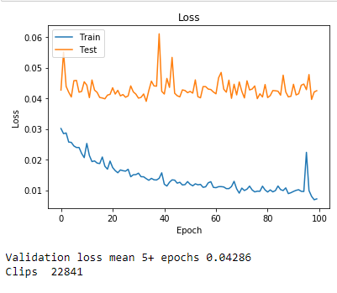

Clips is actually frames

Can see that although training error continues to go down, verification error gets stuck early. Need more training data to avoid overfitting.

500 clips, same model

Saving clips to file so I can stream them through the NN, seems slower but memory usage is way lower

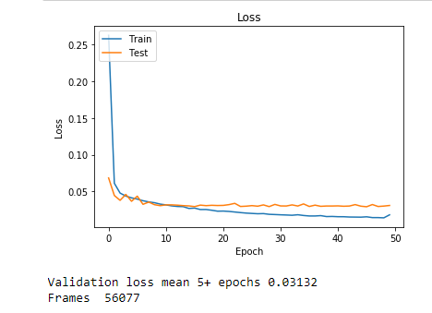

Still plateaus on verification error, but around 0.03 instead of 0.04

Pretty good audio quality on round trip – significant reduction in noise on clip 10, no fuzz

Switch to Lrelu for real
There was a warning about how I was setting the lrelu activation – fixing it seems to have made error higher?

Ran a bunch of tests, get around 0.035 error, audio quality is good, some noise reduction, but not great.

Exploring architectures

Trying some architecture ideas from file:///C:/Users/Dave/Downloads/Monoaural_Audio_Source_Separation_Using_Deep_Convo.pdf

Vertical and then horizontal convolutions, fewer layers

Key idea is that we are not looking for invariants across frequency space, so normal convolution concepts don’t apply

Training on 200 clips
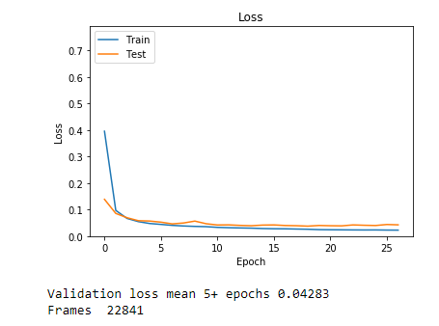

Seems to be over fitting, but training error is around 0.025 which is lowest I’ve ever seen

Trying again with 500 clips

Experimented with regularizers – added kernel_regularizer=regularizers.l2(L2Reg) to every layer with weights
Didn’t work as well – audio quality wasn’t great
Tried L2Reg very small – 0.0001 still not good

Also, big spikes in errors.

Turned L2Reg to zero and no spikes, plus good results again

Moved it up to 0.000001, started blowing up at epoch 40

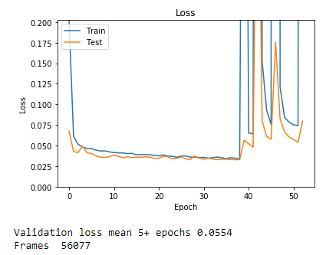

Audio quality sounds about the same – p232_010 noticeably less noise, but still noisy
Average abs err vs clean = 0.2524306676621576
Average cut value = 0.3997907898948629

Model info for the record
__________________________________________________________________________________________________
Layer (type) Output Shape Param # Connected to
==================================================================================================
input_19 (InputLayer) (None, 513, 25, 1) 0
__________________________________________________________________________________________________
conv1 (Conv2D) (None, 1, 23, 256) 394240 input_19[0][0]
__________________________________________________________________________________________________
conv3 (Conv2D) (None, 509, 1, 128) 16128 input_19[0][0]
__________________________________________________________________________________________________
leaky_re_lu_50 (LeakyReLU) (None, 1, 23, 256) 0 conv1[0][0]
__________________________________________________________________________________________________
leaky_re_lu_52 (LeakyReLU) (None, 509, 1, 128) 0 conv3[0][0]
__________________________________________________________________________________________________
convh2 (Conv2D) (None, 1, 1, 128) 753792 leaky_re_lu_50[0][0]
__________________________________________________________________________________________________
conv4 (Conv2D) (None, 2, 1, 48) 3121200 leaky_re_lu_52[0][0]
__________________________________________________________________________________________________
leaky_re_lu_51 (LeakyReLU) (None, 1, 1, 128) 0 convh2[0][0]
__________________________________________________________________________________________________
leaky_re_lu_53 (LeakyReLU) (None, 2, 1, 48) 0 conv4[0][0]
__________________________________________________________________________________________________
flatten_22 (Flatten) (None, 128) 0 leaky_re_lu_51[0][0]
__________________________________________________________________________________________________
flatten_23 (Flatten) (None, 96) 0 leaky_re_lu_53[0][0]
__________________________________________________________________________________________________
concatenate_13 (Concatenate) (None, 224) 0 flatten_22[0][0]
flatten_23[0][0]
__________________________________________________________________________________________________
dense_19 (Dense) (None, 700) 157500 concatenate_13[0][0]
__________________________________________________________________________________________________
dense_20 (Dense) (None, 300) 210300 dense_19[0][0]
__________________________________________________________________________________________________
input_20 (InputLayer) (None, 513, 1, 1) 0
__________________________________________________________________________________________________
leaky_re_lu_55 (LeakyReLU) (None, 300) 0 dense_20[0][0]
__________________________________________________________________________________________________
flatten_24 (Flatten) (None, 513) 0 input_20[0][0]
__________________________________________________________________________________________________
concatenate_14 (Concatenate) (None, 813) 0 leaky_re_lu_55[0][0]
flatten_24[0][0]
__________________________________________________________________________________________________
dense_21 (Dense) (None, 513) 417582 concatenate_14[0][0]
==================================================================================================
Total params: 5,070,742
Trainable params: 5,070,742
Non-trainable params: 0

New architecture

Adding input again one step earlier
Also found that I wasn’t using applying lrelu to my second dense layer :(

Considering adding pooling back to get more depth in current 48 deep conv

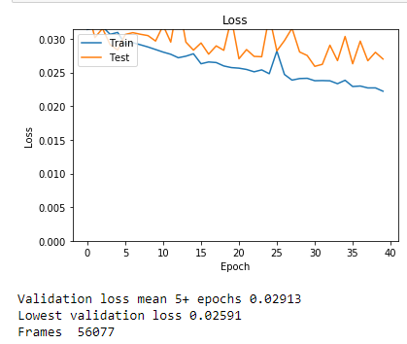

Much better results, and was still dropping at 40

Average abs err vs clean = 0.2334
Average cut value = 0.432

Created more clips from same set (memory map into giant file on F)

Testing with 89K samples instead of 56K (using all of the test clips)

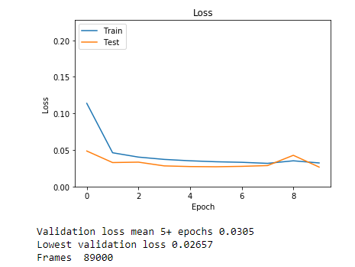

Decent audio quality after 10 epochs, but nothing unusual

Back to cqt

Need more consistent scale between pitches if we want any kind of ‘translation’ to work across bins, so this needs to work.
Also makes distribution of useful data more consistent.

Basically good – fixed quality problems with round trip (smaller hop length)

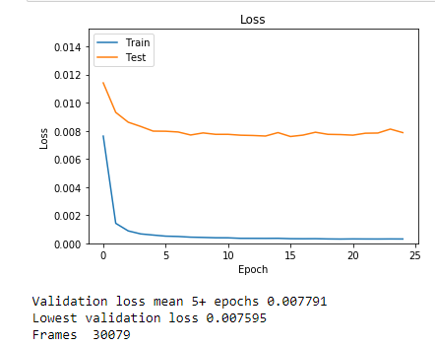
Errors are very low (but different scale since it’s a new representation)

Try with way more frames

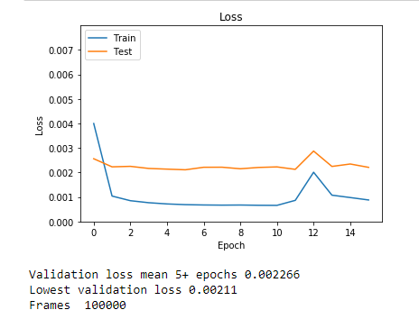

Good on removing noise, but some bad buzzing

Trying much different model (no long slices, all one stack)

Jan 19

Using fit generator and google collab for large scale data, as well as big & narrow windows

Got to very low errors (0.0009), but round trip results were poor
Experimenting with perfect information round trip, seems like using ‘clean’ magnitude for cqt data on the ‘noisy’ phase still results in noisy results (similar to get I’m seeing with the very good NN results when I use them to round trip)

Going back to fft to see if that’s better (unfortunately means giving up on the nice interpretation of topology for the input)

> Simple FFT avoids issues with round trip, but error levels are much higher (0.03 rather than below 0.001)

Rejigging NN for more complexity

Hard clips

Created ‘diff’ calculator and now filter clips for use in training based on reasonable errors (not nothing, but not terrible)
From testing sample, my ‘70 or higher’ error clips are 70% percentile and up of difference – very noticeable noise
Boosted fft bins to 1025 for more data to analyze in NN
Did all of these things, and big changes to NN – errors are now ~1.0, not 0.03!!!
Only took the worst half of clips, so this may be making a big difference

Simplifying

Took on too much, step back until things are better.

Trying 513 bins and lowering the difficulty of clips to 30-100
Want to see if I can get back to reasonable results, then work back one step at a time

Error dropped to ~.025 after 5 epochs, got down to ~0.018 after 45

Round trips generally good with noticeable improvements

Added comple xity to NN, made it deeper, best error after 50 is 0.0161

Added testing on noise ratios
Example results for 50 clips
Average : 0.94
90% pct 1.72

Trained NN for 100 epochs (I think? Output died in colab at 14)
As of 14, val_loss was 0.209
Average : 0.72
90% pct 1.22

Trying with side bus and batch size 128 (300K samples) – slow but steady progress on loss & val_loss
10 epochs, val_loss: 0.0184

These results represent a significant improvement in all of the clips, and the bad ratios are almost entirely about increases in error for the ones with lowest original error (so model noise scores may be the best representation)
Ratios
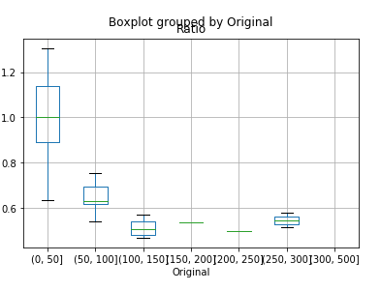
Average: 0.45
Percentiles
0.25 0.273109
0.50 0.480769
0.75 0.643939
0.80 0.672464
0.90 0.726064

Model noise scores
Average: 45.94
Percentiles
0.25 29.477886
0.50 34.649619
0.75 53.637676
0.80 54.263257
0.90 64.056819

Batch upped to 256, bus width to 150, reduction in dense 1 to 500 from 700 (and then 300 and 200 for D2 D3)
Grabbed after 12 epochs, val_loss 0.0168
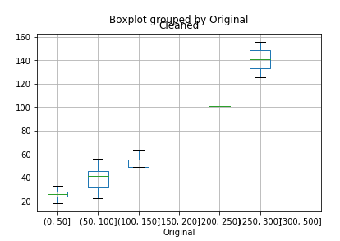
Slightly worse
Model noise scores
Average: 47.62
Percentiles
0.25 28.635362
0.50 34.551257
0.75 53.290065
0.80 57.006282
0.90 84.768071

Another 36 epochs
val_loss: 0.0125

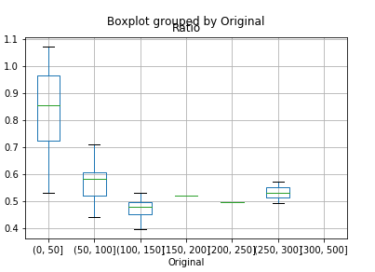
Model noise scores
Average: 43.62
Percentiles
0.25 25.507939
0.50 30.387622
0.75 49.195775
0.80 52.719862
0.90 82.143519

Running more training on same model
val_loss 0.0092
Model noise scores
Average: 43.10
Percentiles
0.25 25.378660
0.50 30.000978
0.75 47.936276
0.80 51.469258
0.90 80.461041

At about 0.0090 loss continues steadily down each epoch, but val_loss has been stuck around 0.01 going down to
loss: 0.0076 - val_loss: 0.0102
Leads to incrementally better results even though val_loss is unchanged
Model noise scores
Average: 42.47
Percentiles
0.25 25.037424
0.50 29.678856
0.75 47.680440
0.80 51.467596
0.90 80.001497

Jan 25 - Back to CQT

Steady progress but not close enough

Switch to CQT, but using complex values not trying to use magnitude and then reuse phase from noisy source for rebuilding (since that didn’t work for cqt)

Added magnitude version of complex inputs and process is as a path, also magnitude comparison for custom error function

Not great results.

Tried magnitude and phase, but phase messes up error. Tried custom phase error, but no modulo function in Keras backend

Saw a suggestion to work with cos & sin of phase instead, and then arctan to get the angle out – try that next

Feb 2 – CQT experiments

Using cos & sin of phase as inputs to avoid needing to use arctan – so now 3 layer

Many experiments with scale & bias – did get it working but without great results, then got stuck on issues matching shapes ?
Back to just merging input into final layer – uses a ton of weights

Added ‘harmonic’ function that shifts inputs up by an octave and overlays on another copy of inputs

Tried simplifying network with no ‘bus’ and no narrow view – not very good results (0.3 error and then it seems to stop)

Up to Mar 4 – scaled FT to get ‘pitch’ space

Cut high and low frequencies, reduced from 513 bins to 337 with no perceptible loss of quality
Rescaled using log2 and power of 2 so that pitches were evenly spaced

Works OK but remapping to noisy phase adds static

Experiments with many different networks – best errors come in around 0.045

Experience of the round trip is significant reduction in original noise, but addition of ‘static’

Mar 3 – FT split by frequencies

https://www.behindthemixer.com/how-eq-speech-maximum-intelligibility/
Says 6K is max area to pay attention to, so I can lower my high cut off further

Concepts
- go back to FT around Jan 25 where I got the best results
- reduce down to 337 bins like above (maybe even fewer) to avoid training on useless content
- separate ‘voiced’ frequencies from high frequency areas for consonants for different training

Starting with first two…

300K samples, 10 epochs, 300s each, 0.03 val_loss
Quick test of round trip audio shows good noise reduction

20 epochs, 0.023, (but same val_loss for past 3 epochs), very good audio results

NOTE – even in STFT there noticeable fuzz from using the wrong phase
Round trip results in an error of 0.03 (or 0.09 in another clip) in absolute error for FT!!
May mean I have to deal w/ phase after all...

More training – seems to be plateau at val_loss 0.0015 (very close for 15 epochs) although training loss continues to go down (at 0.0013)

Going to 1M samples jumped the error up, then back to 0.025 (still dropping), about 15 minutes per epoch

Made it much more complicated (up to 7M weights and more layers) – takes 30 minutes per epoch and not noticeably better

Future
- Add scale & bias layer based on inputs for calculating output
- Train delta phase (add NN output to input phase right before returning as predicted phase)
- Add logging to tensorboard to deal with UI refresh stalls +
https://medium.com/@kuanhoong/how-to-use-tensorboard-with-google-colab-43f7cf061fe4
- Create custom noisy clips for my problem (also remove female speakers and look for lower voiced male)
- Sample road noise and squeaks
- try PESQ speech quality evaluator as a measure of output quality

